Excel Assignment - 6

1. What are the various elements of the Excel interface? Describe how they're used.

2. Write down the various applications of Excel in the industry.

3. On the ribbon, make a new tab. Add some different groups, insert commands in the groups and name them according to their commands added. Copy and paste the screenshot of the steps you followed.

4. Make a list of different shortcut keys that are only connected to formatting with their functions.

5. What distinguishes Excel from other analytical tools?

6. Create a table and add a custom header and footer to your table.

1. The Following are a few of the elements in Microsoft Excel

Quick Access Toolbar, File Tab, Title Bar, Control Buttons, Menu Bar, Formula Bar

Quick Access Toolbar - Its main objective is to show the most frequently used Excel commands

File Tab – it is used to check the backstage view where we can open, save, create new sheets & perform other file-related operations.

Title bar – Displays Active Documents Name

Control Buttons – present at the upper-right side of the window. Helps to change the labels, minimize, maximize, share & close sheets

Menu Bar – Contains File, Insert, Page, Layout, Formulas, Data, review, view, Help, Search Bar

1. Few of the applications of Excel in Industry are: -

* Data Entry
* Data Management
* Financial Accounting
* Accounting
* Programming
* Financial Modelling
* Charting & Graphing

1. The following Screenshots depict the procedure to create a new tab in Excel with desired commands in it -

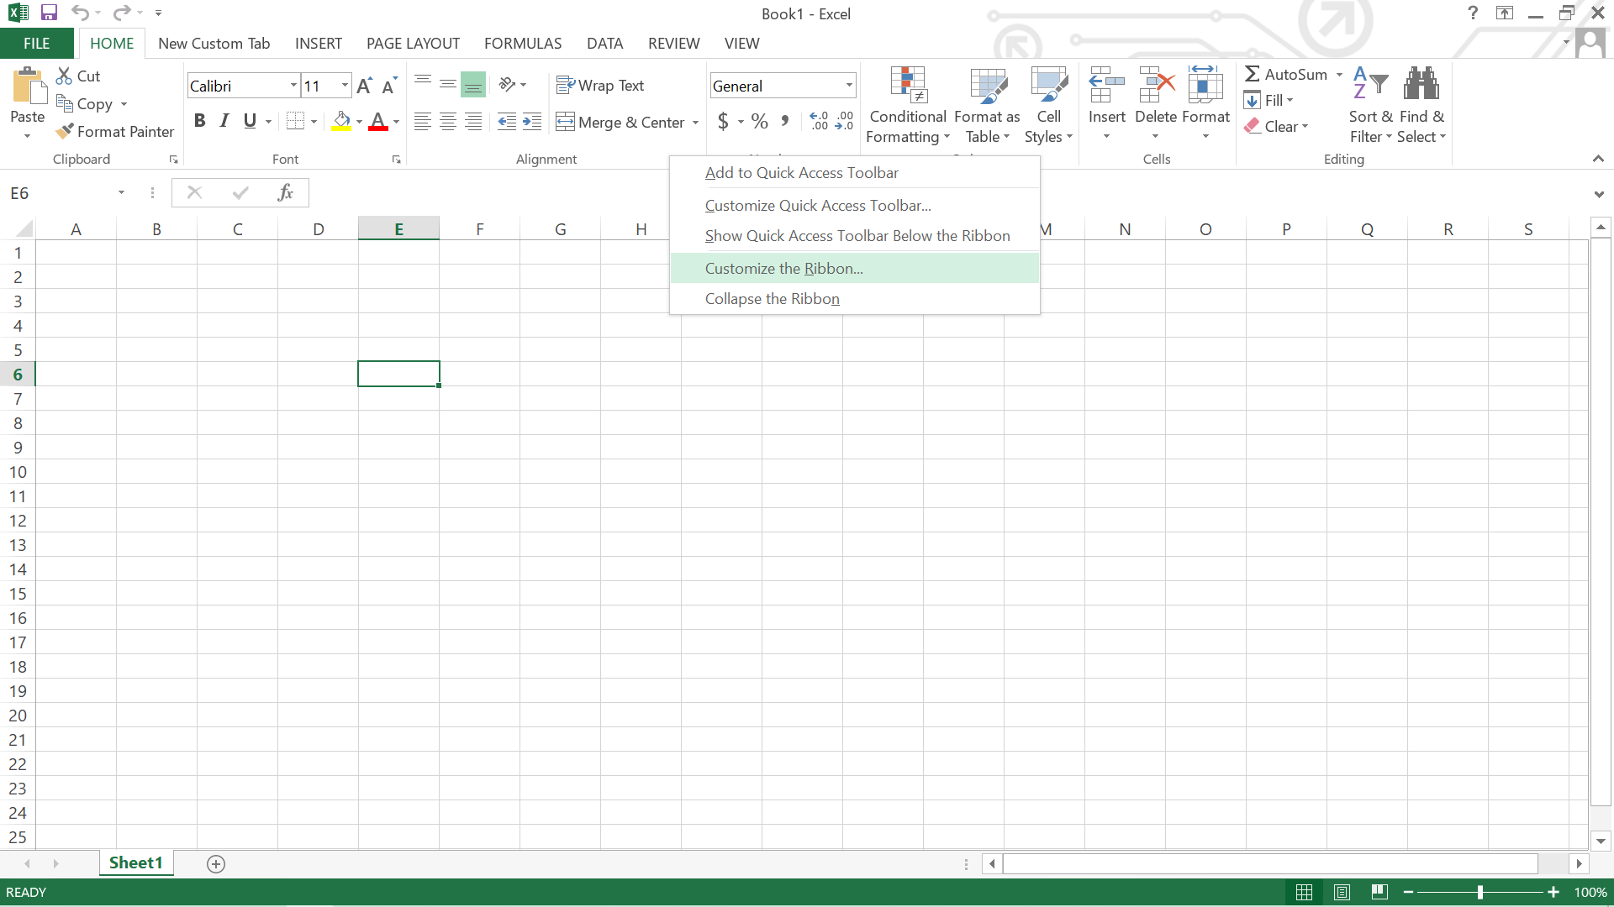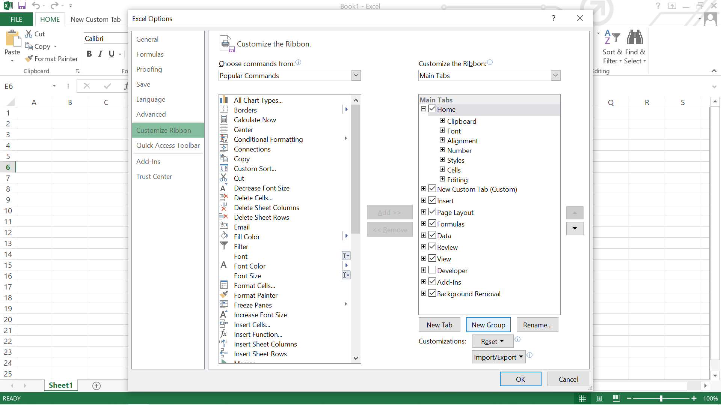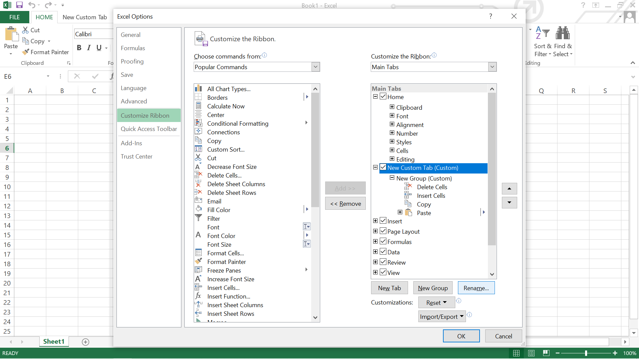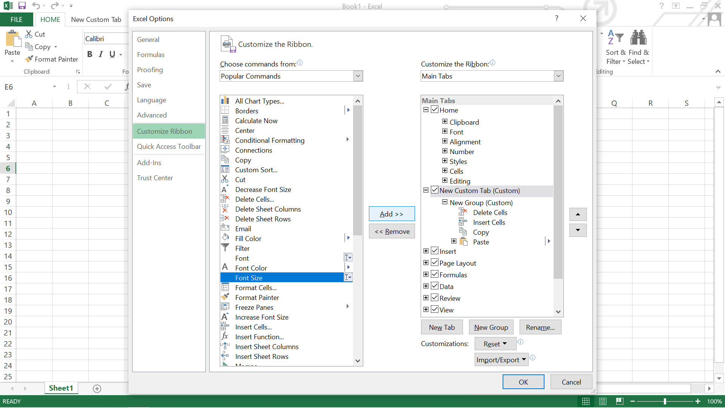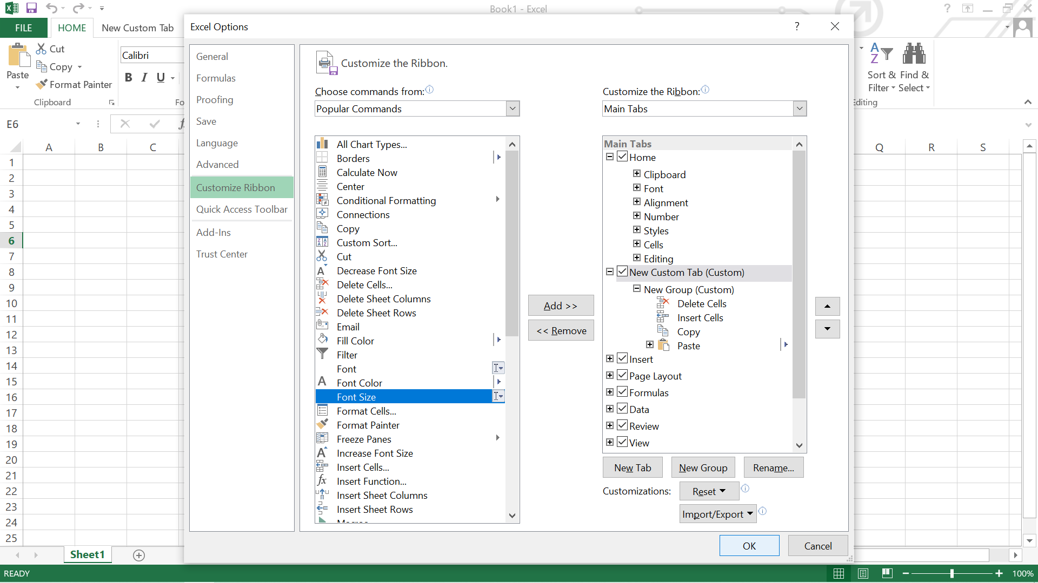

1. The few shortcuts are -

* Ctrl + C → Copy selected text or graphics to the Office Clipboard.
* Ctrl + V → Paste the most recent addition to the Office Clipboard.
* Ctrl + Shift + A → Format all letters as capitals.
* Ctrl + B → Applies or removes bold formatting.
* Ctrl + I → Applies or removes italic formatting.
* Ctrl+= → Apply subscript formatting (automatic spacing).
* Ctrl + A: Select all contents of the page.
* Ctrl + B: Bold highlighted selection.
* Ctrl + C: Copy selected text.
* Ctrl + X: Cut selected text.
* Ctrl + P: Open the print window.
* Ctrl + F: Open the find box.
* Ctrl + I: Italic highlighted selection.

1. The following are the reasons why excel benefits & distinguishes different from others as an analytical tool

* It builds the charts
* It makes use of conditional formatting
* It helps to organize the data
* It will identify trends
* It provides online access.

